**User Guide**

**Create new member**

1. Firstly, if you want to create a new member, please enter “n” when the system asking for Enter command.

2. Secondly, if the new member which is belong to GoodHealth Fitness Corporation, please enter “gh”or enter”gf” with the member which is belong to GrantFitness Corporationwhen the system asking for Enter company code(gh/gf).

3. Finally,please enter the new member’s id, name, phone and hours with following format(id,name,phone,hours) when the system asking for Enter id,name,phone number,hours.

Create new member with GoodHealth Fitness Corporation:

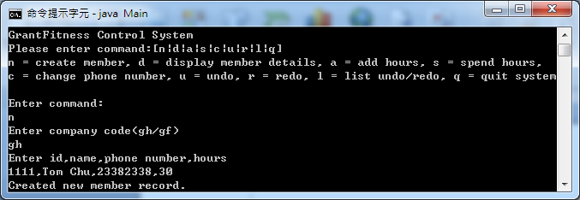

Create new member with GrantFitness Corporation:

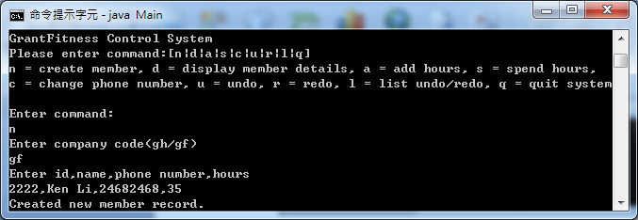

**Display member details**

1. Firstly, if you want to display the member details, please enter “d” when the system asking for Enter command.

2.Finally, if you want to check a member’s details, please enter member’s id or enter “*” for display all member’s details when the system asking for Enter id(* to show all).

Display a member’s details

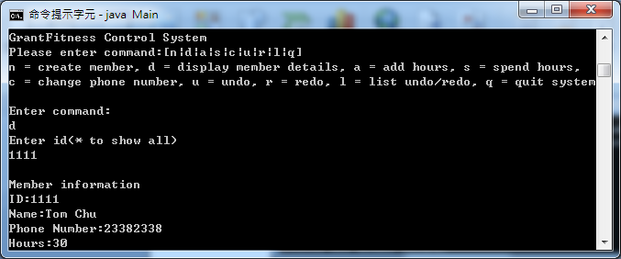

Display all members' detail

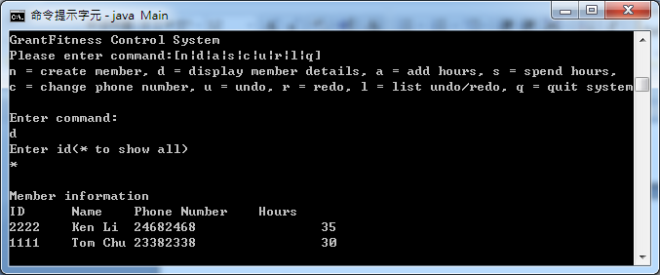

**Add member hours**

1. Firstly, if you want to add the member hours, please enter “a” when the system asking for Enter command.
2. Finally, please enter member’s id and hours with following format (id,hours) when the system asking for Enter id,hours.

Show the result after adds member hours.

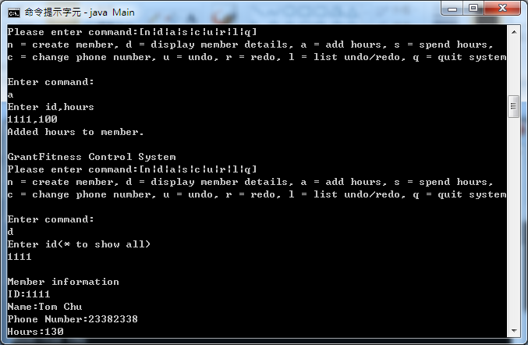

**Deducted member hours**

1. Firstly, if you want to deduct the member hours, please enter “s” when the system asking for Enter command.
2. Finally, please enter member’s id and hours with following format (id,hours) when the system asking for Enter id,hours.

Show the result after deducts member hours.

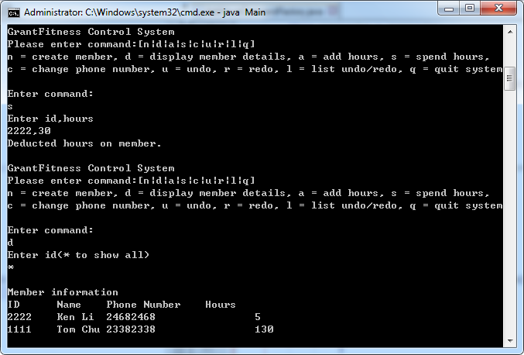

**Change member phone number**

1. Firstly, if you want to change the member phone number, please enter “c” when the system asking for Enter command.
2. Finally, please enter member’s id and newphone number with following format (id,new phone number) when the system asking for Enter id,new phone number.

Show the result after change member phone number.

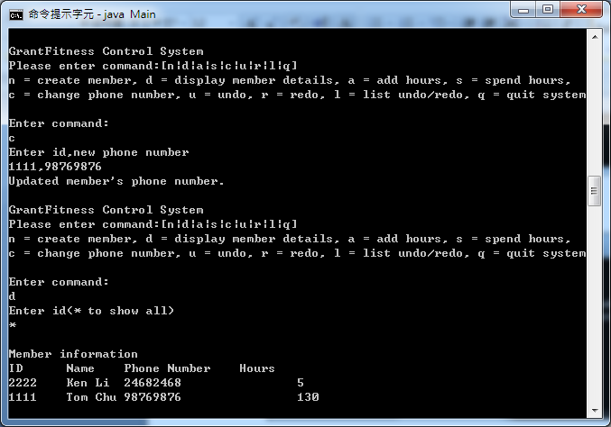

**Undo last command**

1. Firstly, if you want to undo the last command, please enter “u” when the system asking for Enter command.

Undo last command

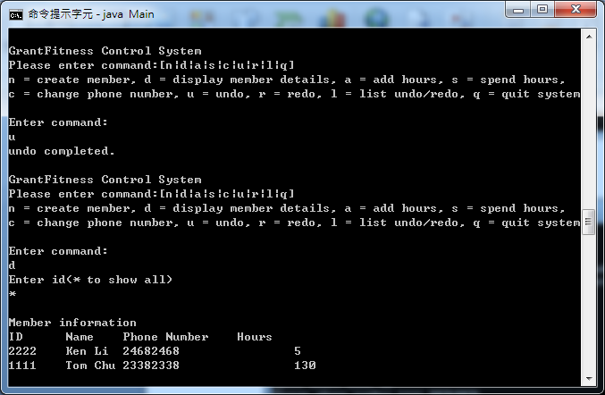

**Redo last command**

1. Firstly, if you want to redo the last command, please enter “r” when the system asking for Enter command.

Redo last command

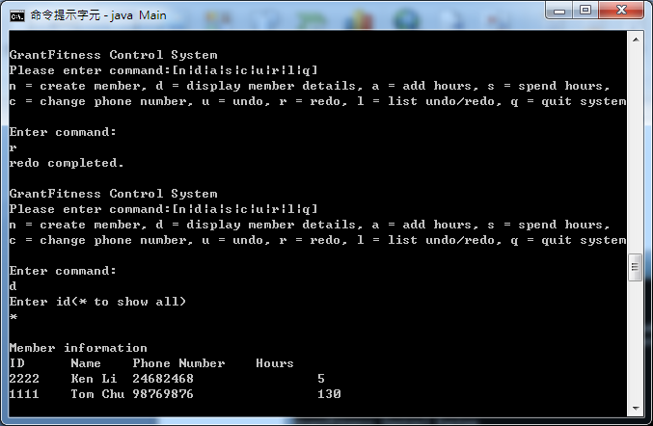

**Show the undo/redo list**

1. Firstly, if you want to show the list of the undo/redo list, please enter “l” when the system asking for Enter command.

Show the undo/redo list with enter 2 times undo.

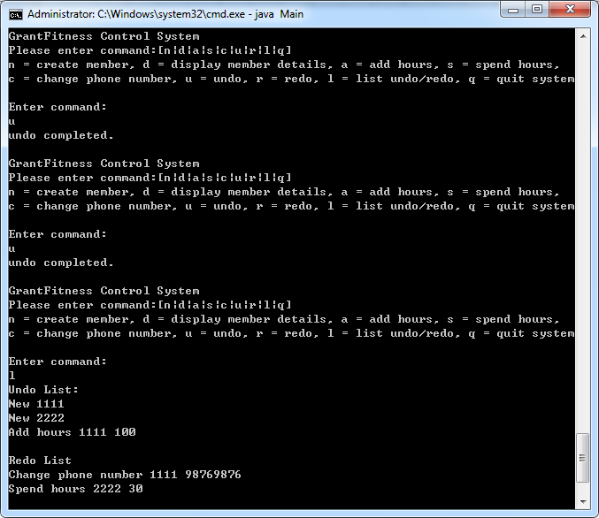

**Leave the system**

1. Firstly, if you want to leave the system, please enter “q” when the system asking for Enter command.

Leave the system.

